

**Green University of Bangladesh**

**Department of Computer Science and Engineering(CSE)**

**Faculty of Sciences and Engineering**

**Semester: (Spring, Year:2021), B.Sc. in CSE (Day)**

**Course Title: Structured Programming**

**Course Code: CSE 104 Section: DE**

**Submission Date :** 25-Jul-22

**Course Teacher’s Name : Md. Atikuzzaman**

**Student Details**

|  |  |
| --- | --- |
| **Name** | **ID** |
| **Md. Israil Fakir** | **221902125** |

**Problems:**

1. **C Program to Check Whether a Number is Even or Odd.**

**Code:**

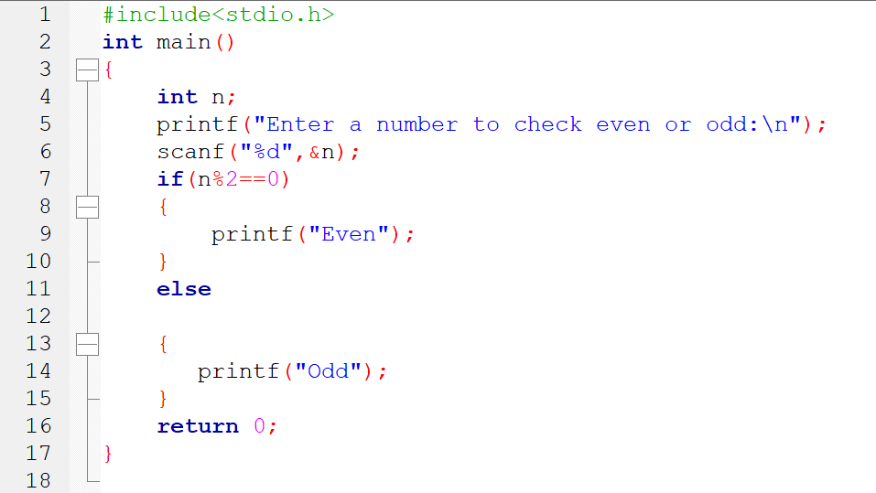

Output:

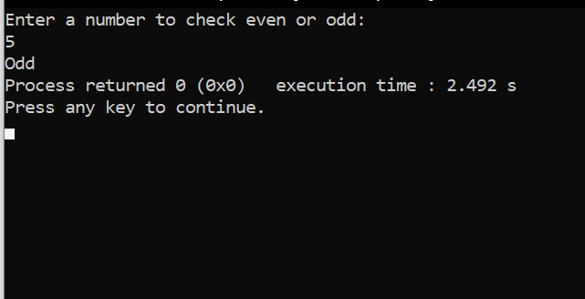

1. C Program to Check Whether a Character is a Vowel or Consonant.

Code:

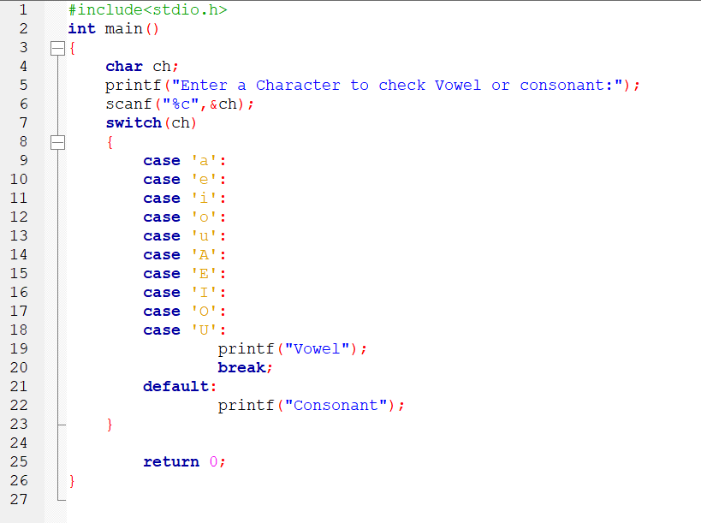

Output:

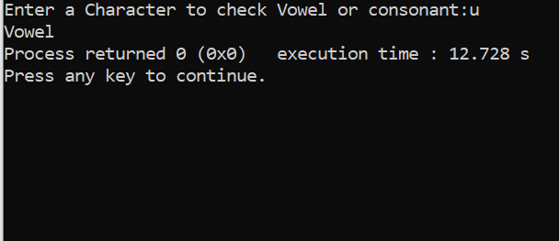

1. C Program to Find the Largest Number Among Three Numbers.

Code:

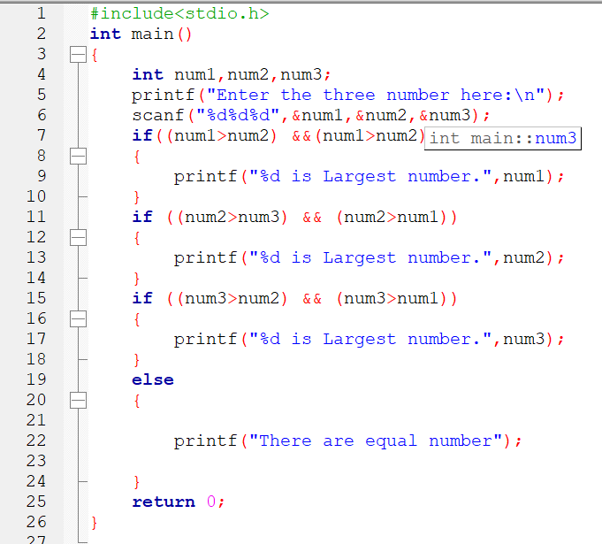

Output:

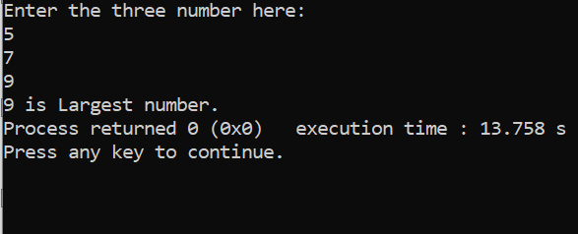

1. C Program to Find the Roots of a Quadratic Equation.

Code:

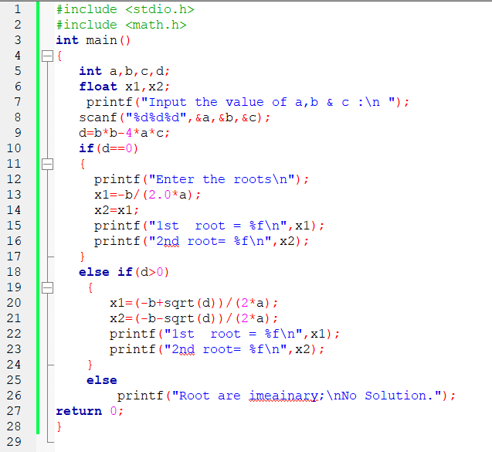

Output:

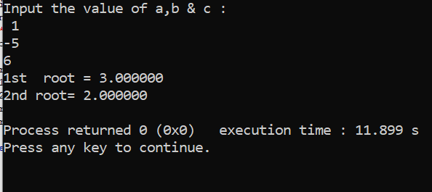

1. C Program to Check Leap Year.

Code:

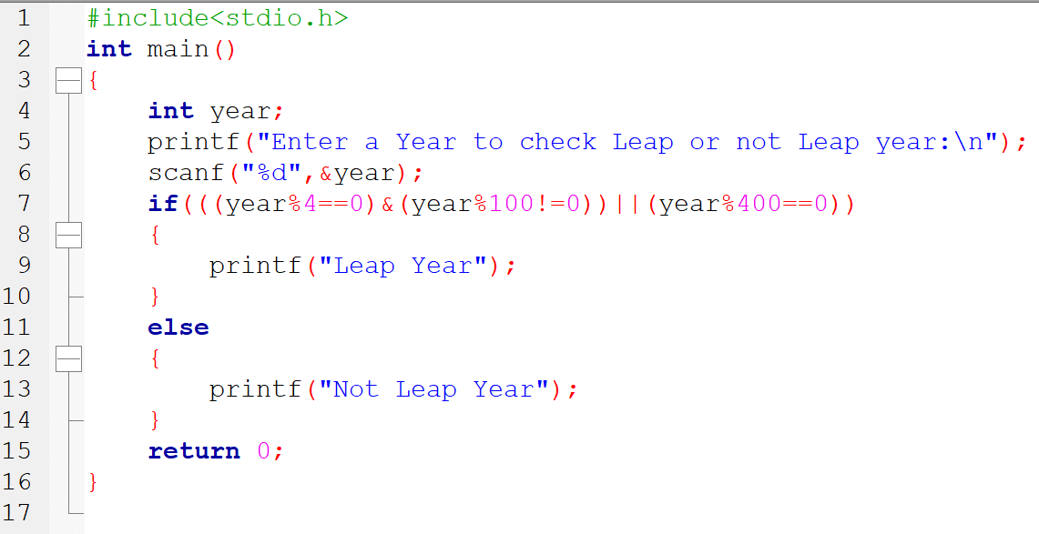

Output:

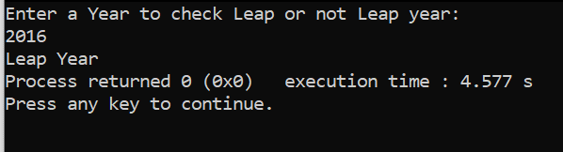

1. C Program to Check Whether a Number is Positive or Negative.

Code:

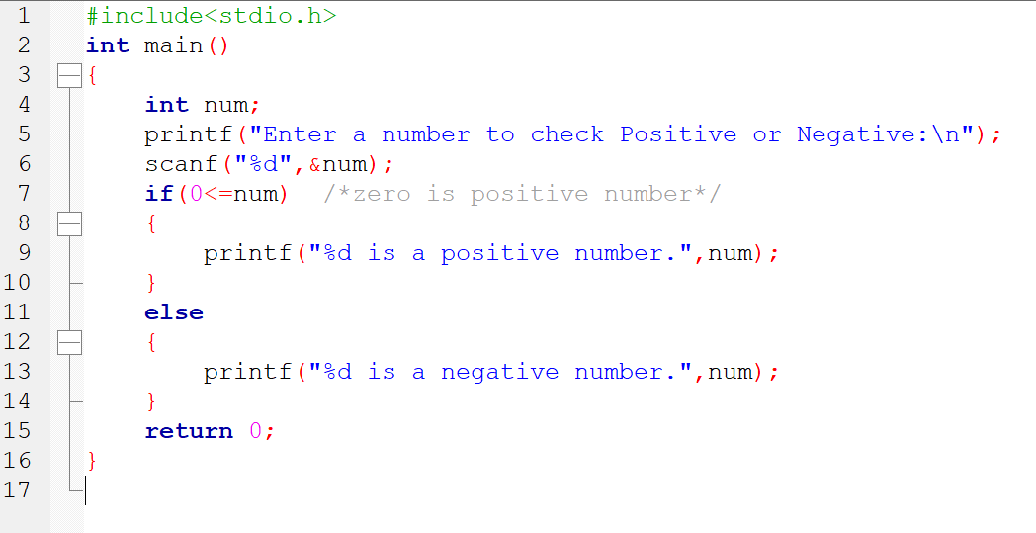

Output:

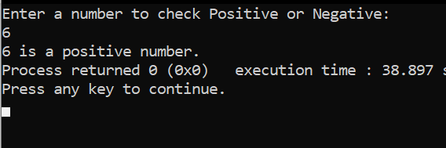

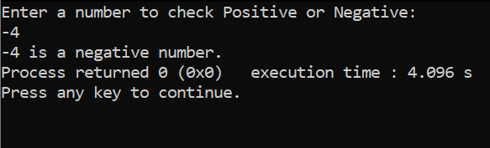

1. C Program to Check Whether a Character is an Alphabet or not.

Code:

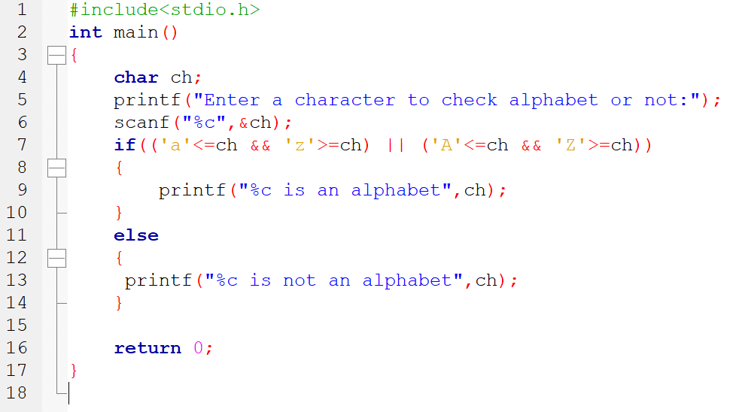

Output:

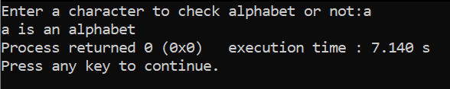

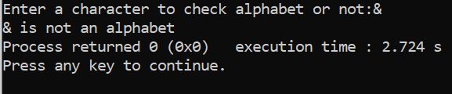

1. C Program to Calculate the Sum of Natural Numbers.

Code:

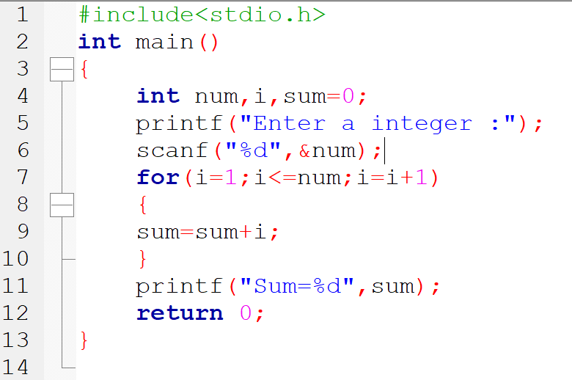

Output:

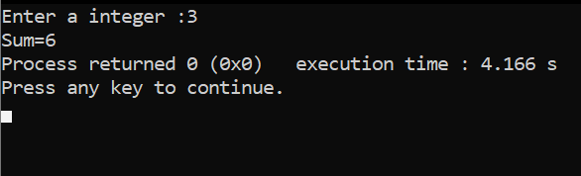

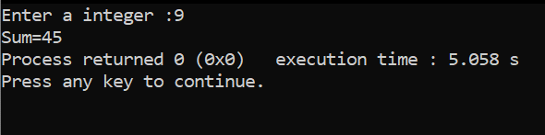

1. C Program to Find Factorial of a Number.

Code:

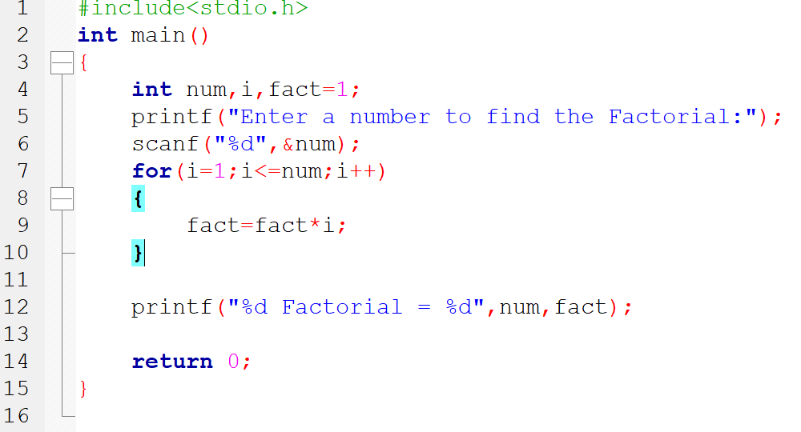

Output:

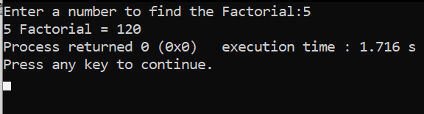

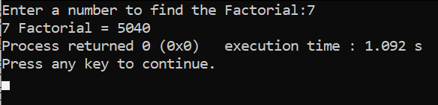

1. C Program to Generate Multiplication Table.

Code:

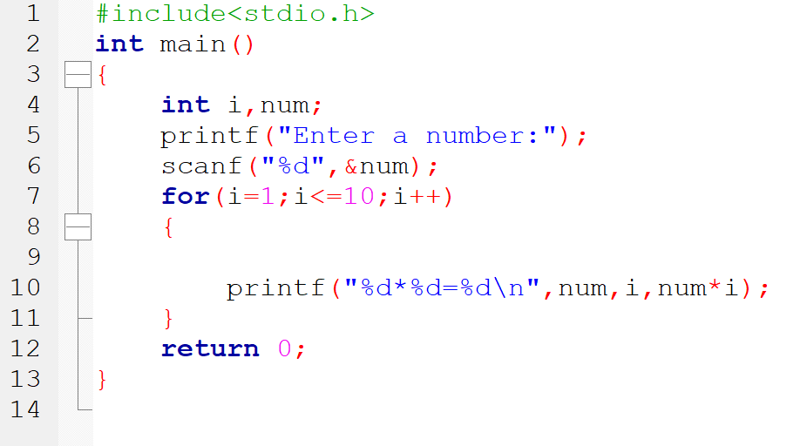

Output:

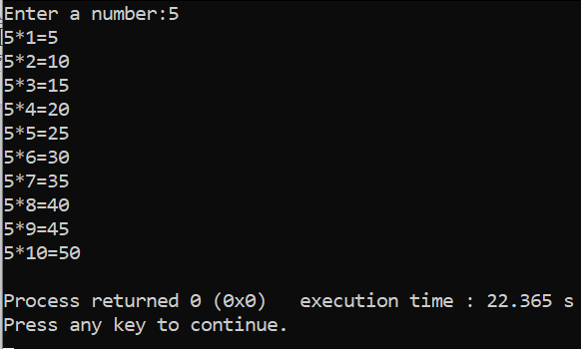

1. C Program to Display Fibonacci Sequence.

Code:

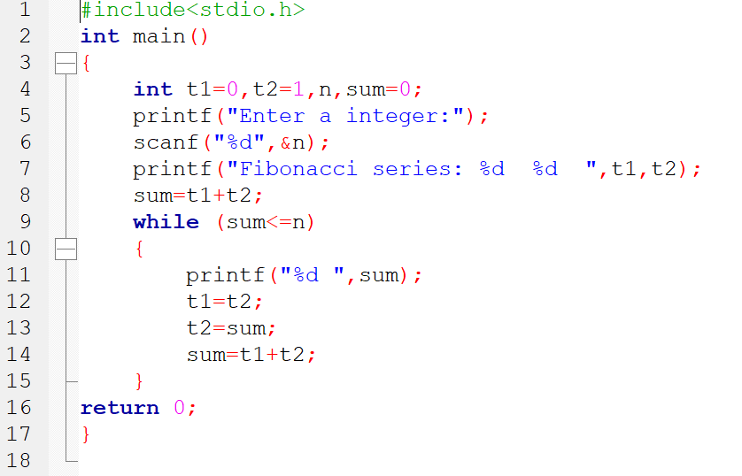

Output:

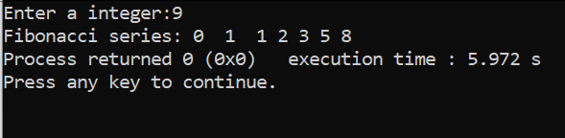

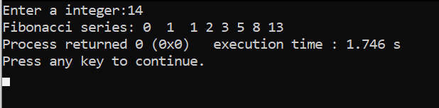

1. C Program to Find GCD of two Numbers.

Code:

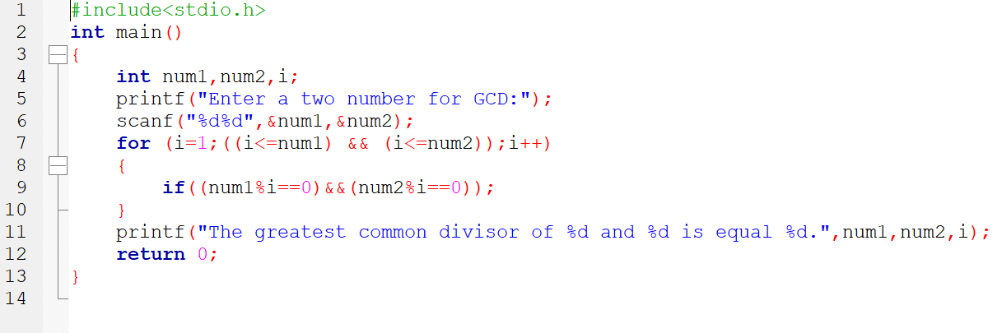

Output:

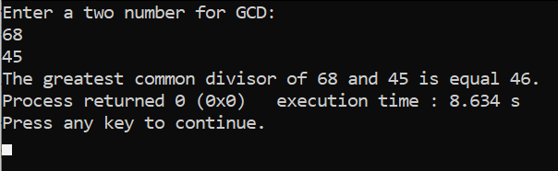

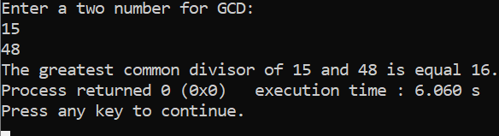

1. C Program to Find LCM of two Numbers.

Code:

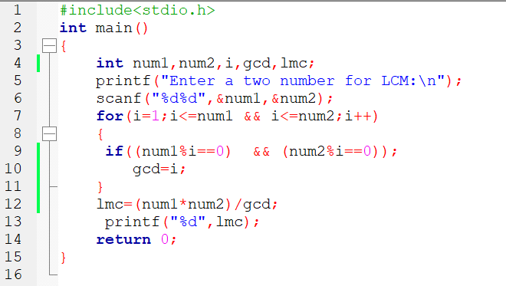

Output:

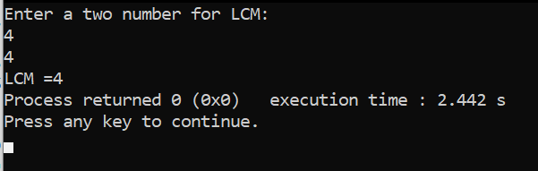

1. C Program to Display Characters from A to Z Using Loop.

Code:

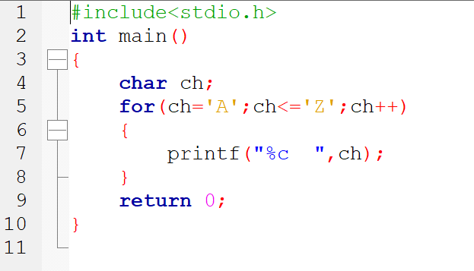

Output:

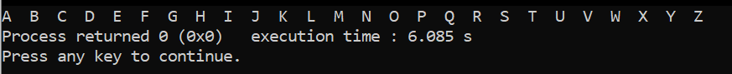

1. C Program to Count Number of Digits in an Integer.

Code:

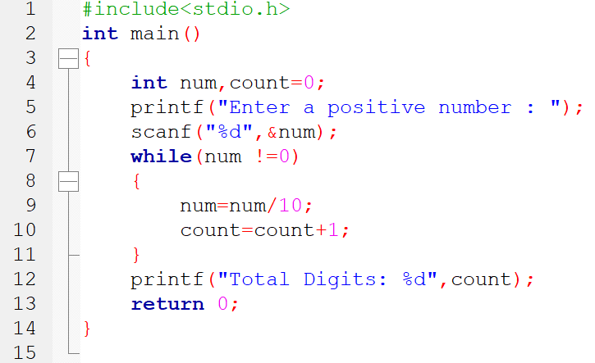

Output:

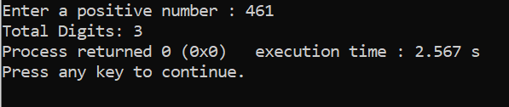

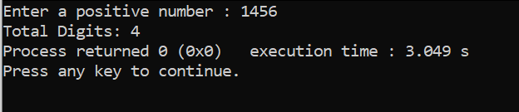

1. C Program to Reverse a Number.

Code:

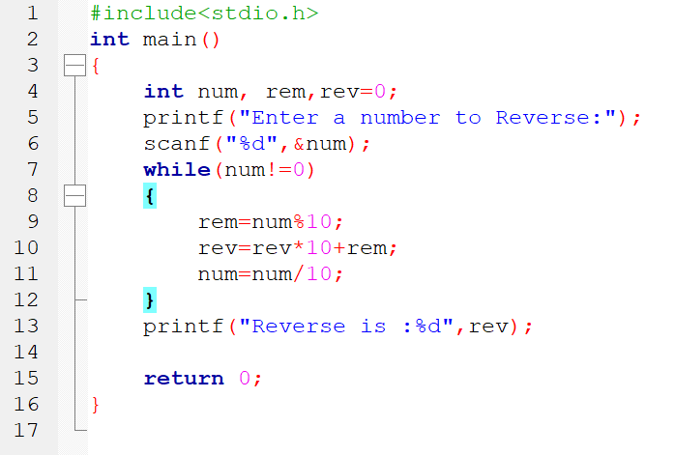

Output:

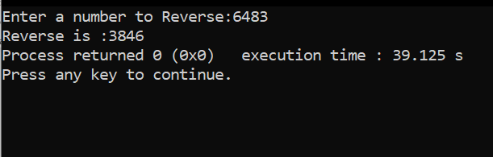

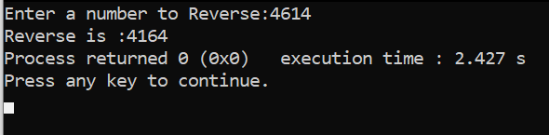

1. C Program to Calculate the Power of a Number

Code:

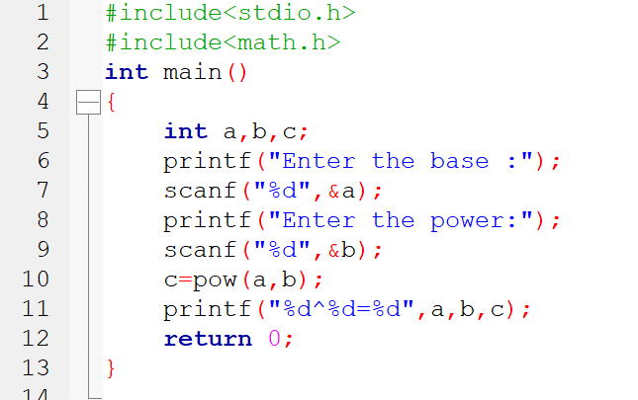

Output:

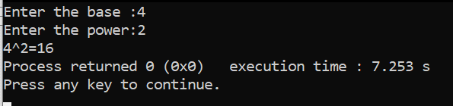

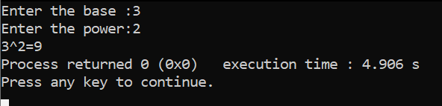

1. C Program to Check Whether a Number is Palindrome or Not.

Code:

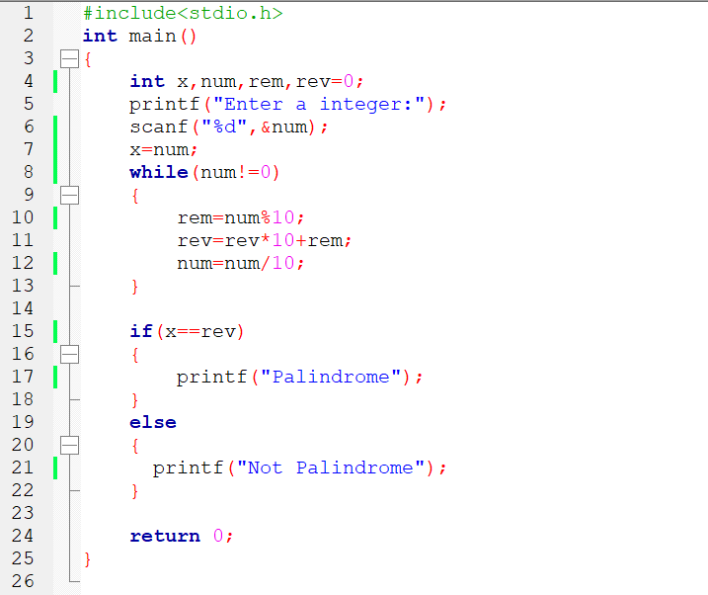

Output:

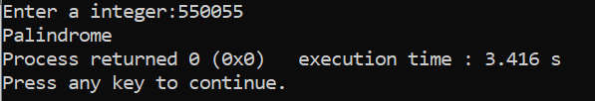

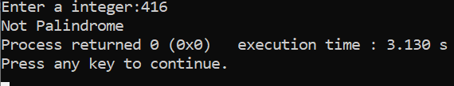

1. C Program to Check Whether a Number is Prime or Not.

Code:

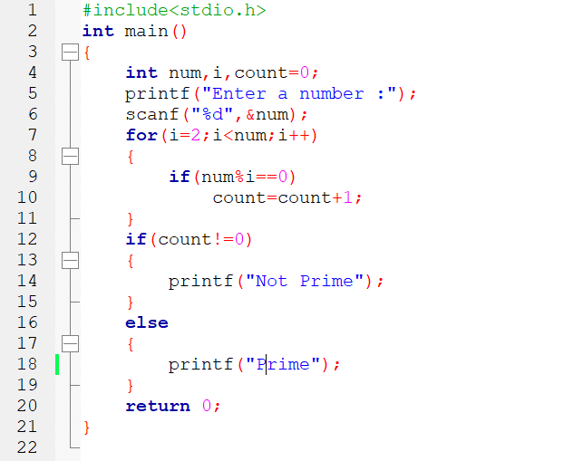

Output:

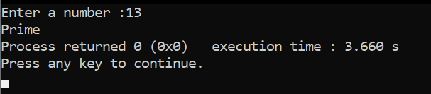

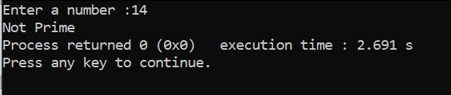

1. C Program to Check Armstrong Number.

Code:

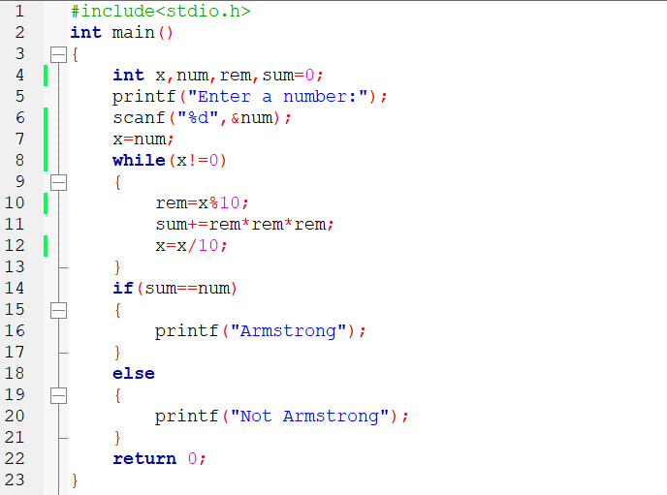

Output:

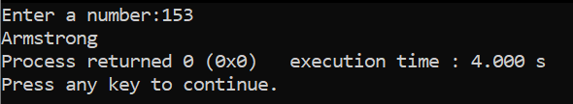

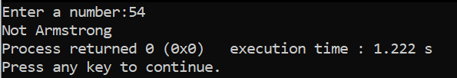

1. C Program to Display Factors of a Number.

Code:

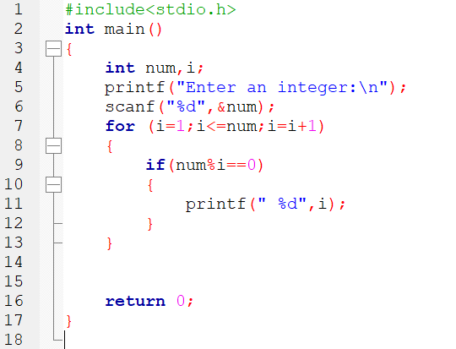

Output:

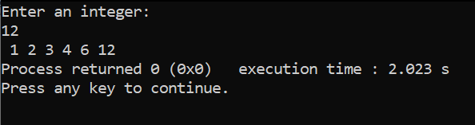

1. C Program to Make a Simple Calculator Using switch...case.

Code:

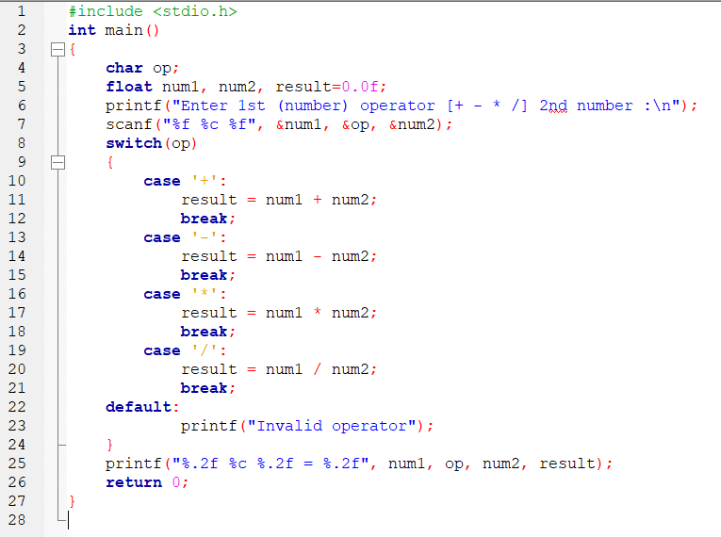

Output:

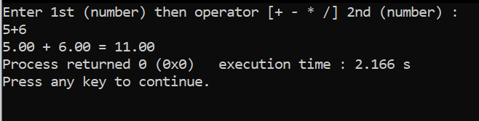

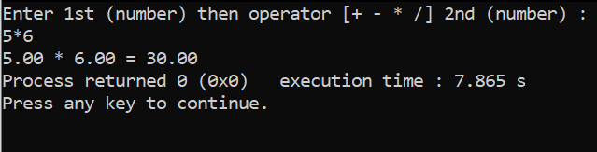

1. C Program to Print Pyramids and Patterns.

Code:

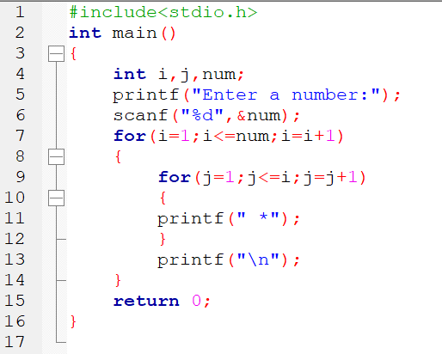

Output:

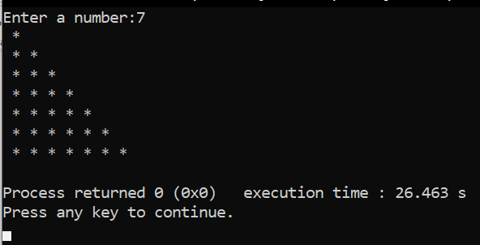

1. Write a C program to accept a coordinate point in an XY coordinate system and determine which quadrant the coordinate point lies.

Code:

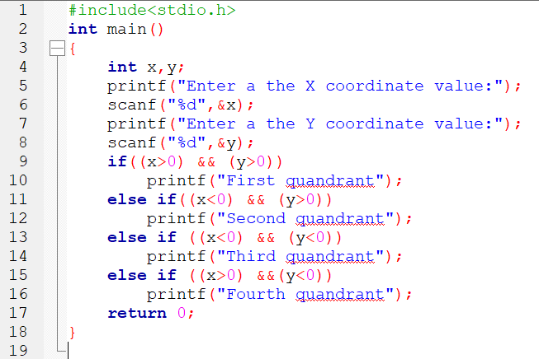

Output:

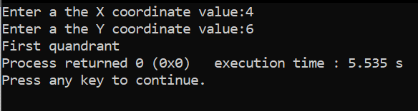

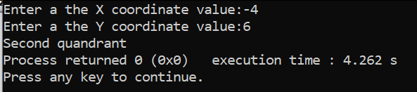

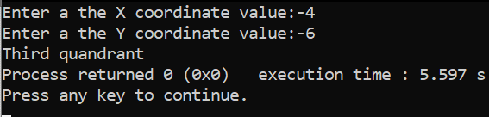

1. Write a program in C to read n number of values in an array and display it in reverse order.

Code:

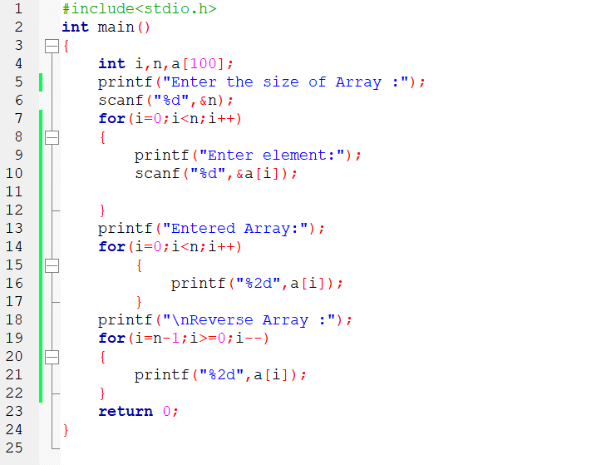

Output:

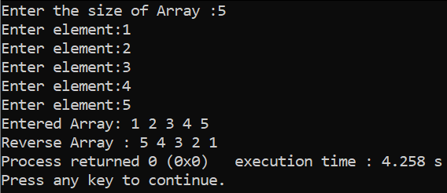

1. Write a program in C to find the sum of all elements of the array.

Code:

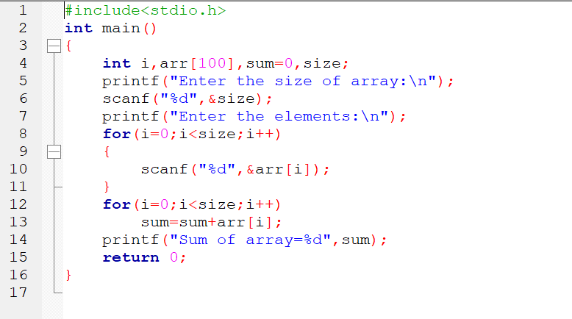

Output:

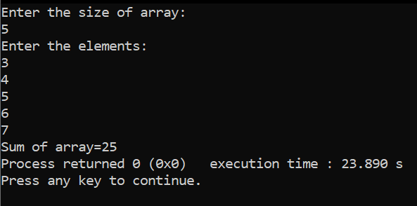

27.Write a program in C to count the total number of duplicate elements in an array.

Code:

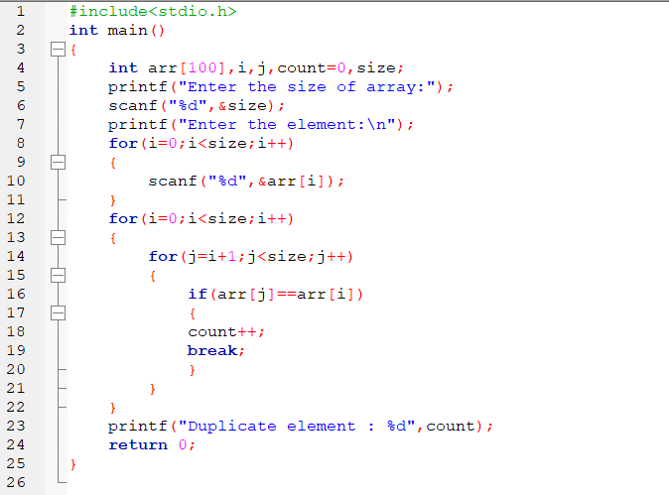

Output:

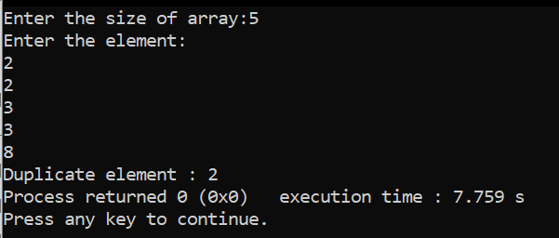

28.Write a program in C to find an array's maximum and minimum elements.

Code:

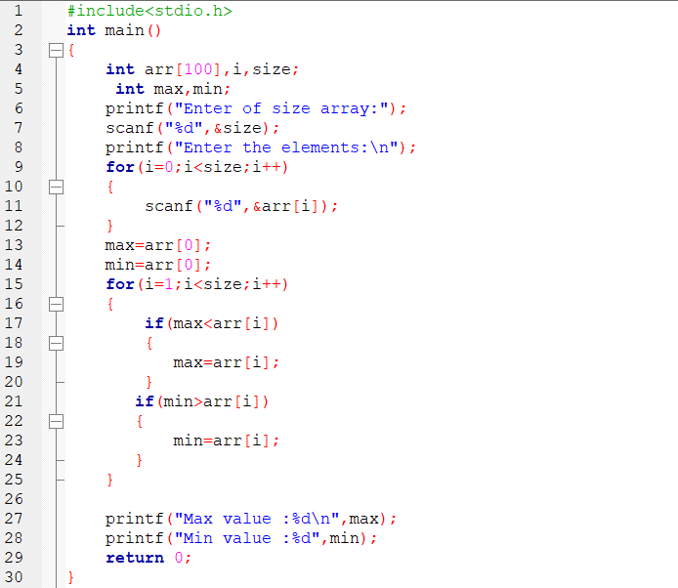

Output:

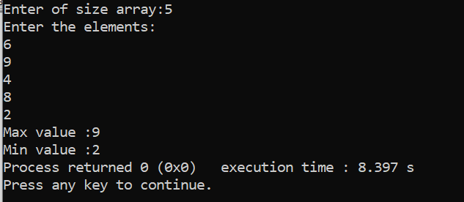

29. Write a program in C to insert a new value in the array (unsorted list ).

Code:

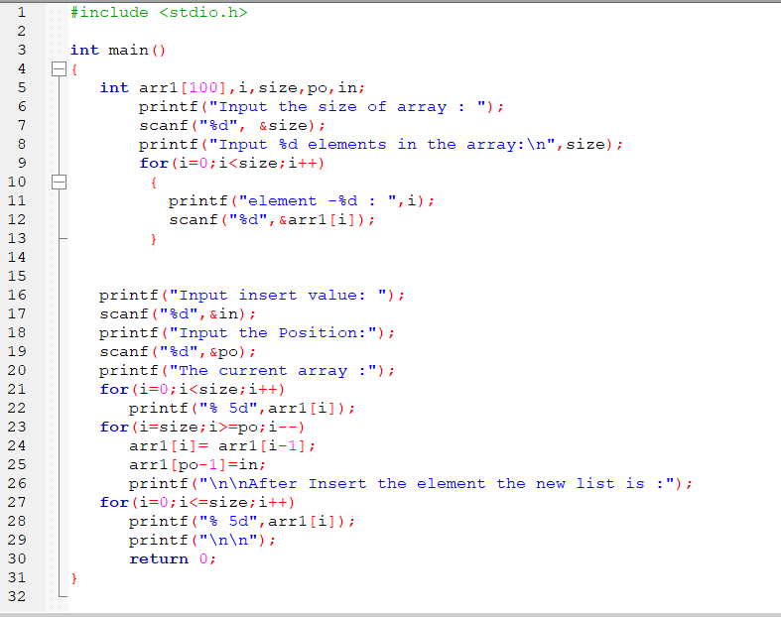

Output:

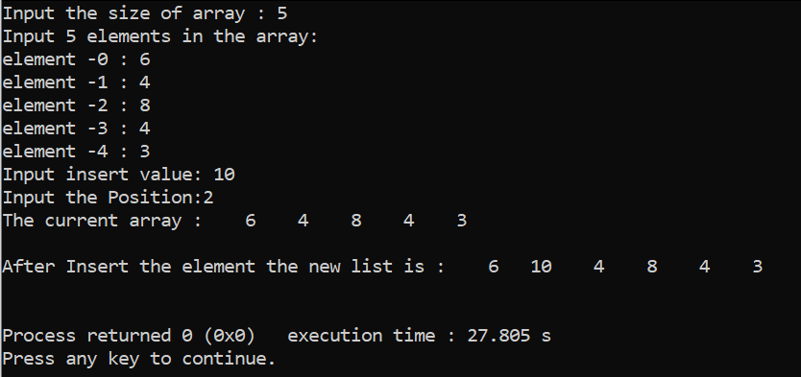

30.Write a program in C to delete an element at the desired position from an array.

Code:

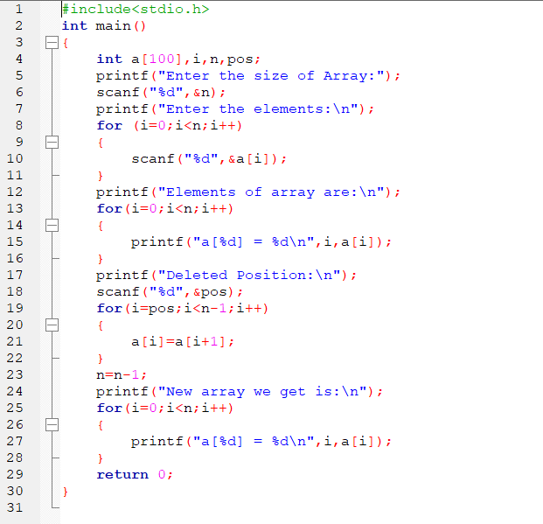

Output:

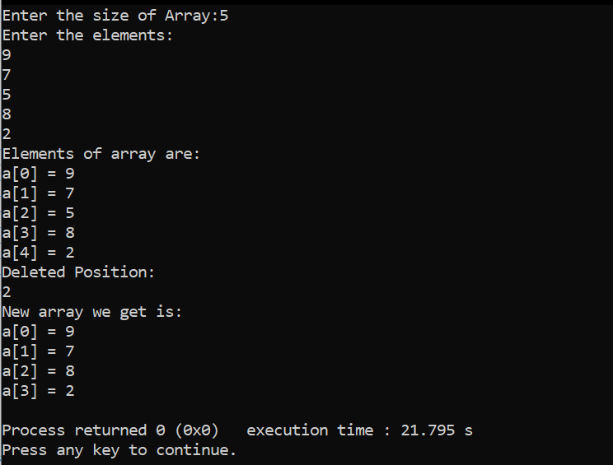

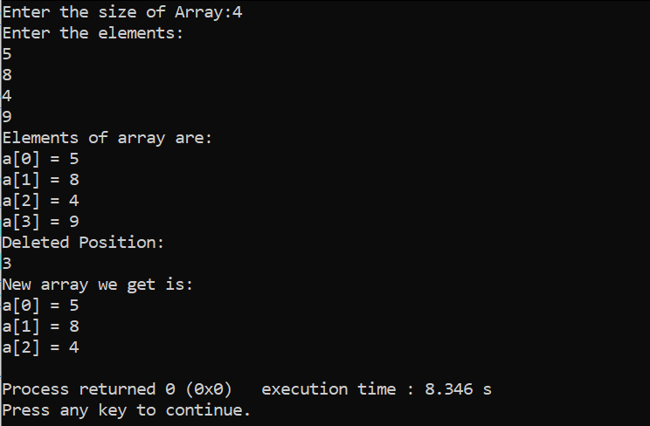

1. Write a program in C to find an element in a given array (Linear search).

Code:

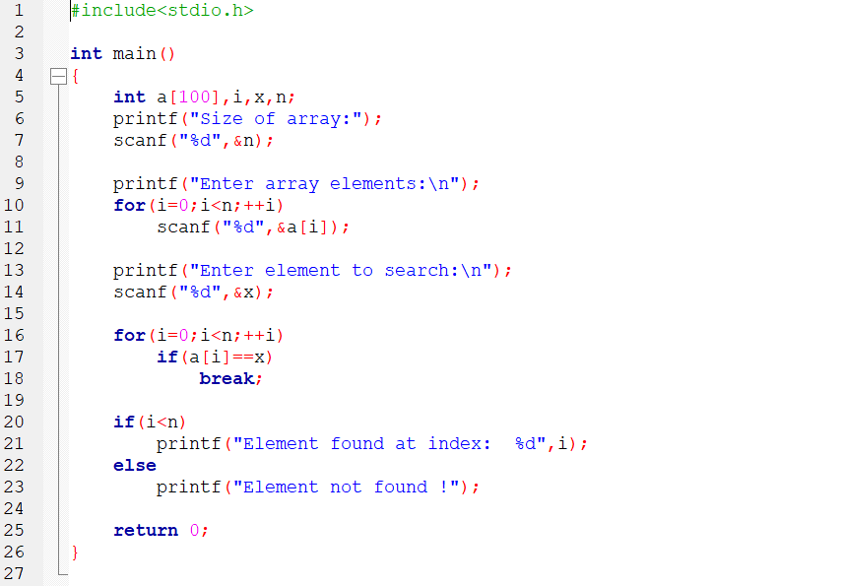

Output:

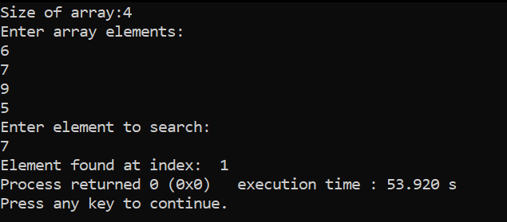

1. Write a program in C to display the sum of the series [ 1+x+x^2/2!+x^3/3!+....].

Code:

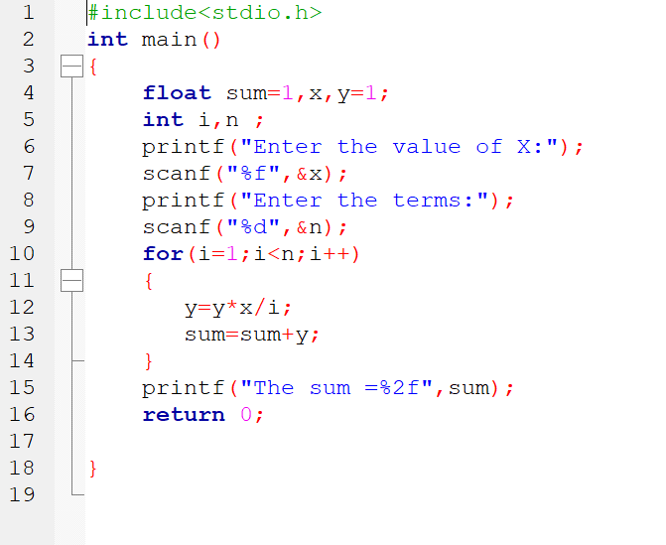

Output:

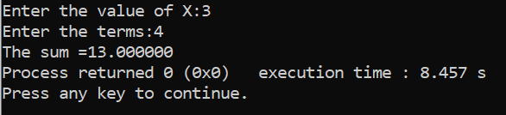

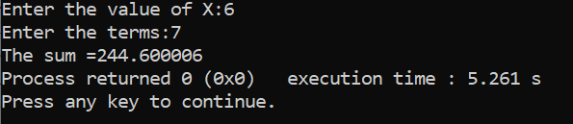

1. C Program to Convert Binary Number to Decimal and vice-versa.

Code:

Binary number to Decimal number:

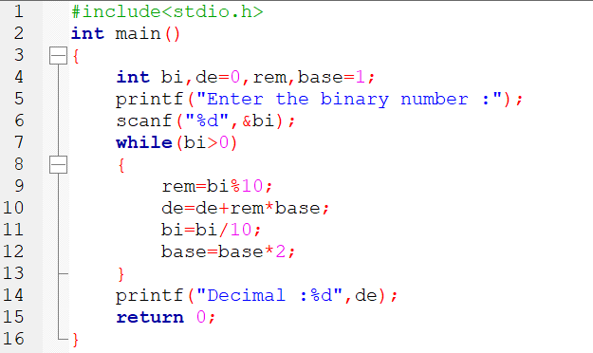

Output:

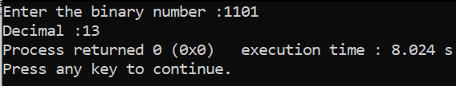

Decimal number to Binary number :

Code:

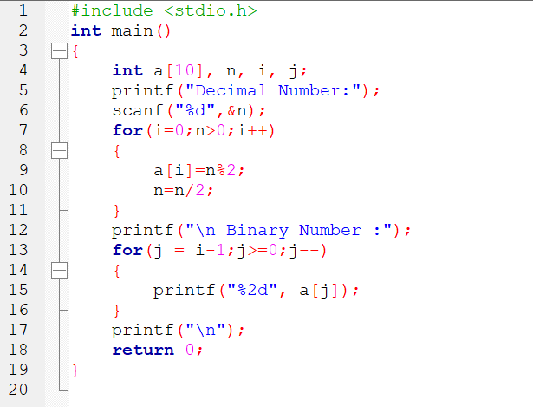

Output:

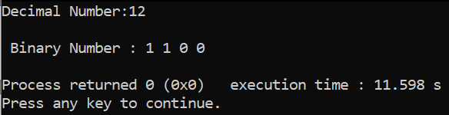

1. C Program to Convert Octal Number to Decimal and vice-versa.

Code:

Octal Number to Decimal number :

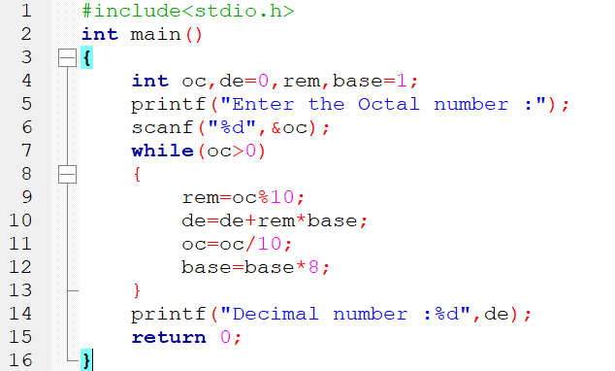

Output:

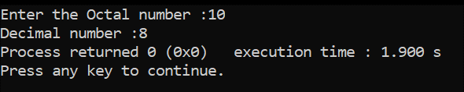

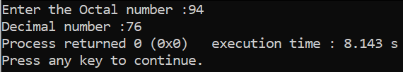

Decimal number to Octal number:

Code :

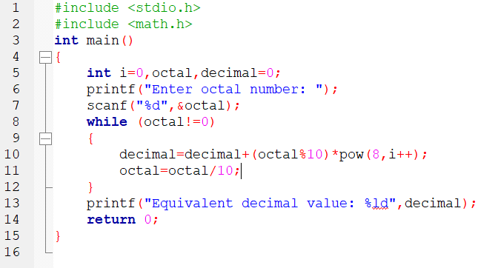

Output:

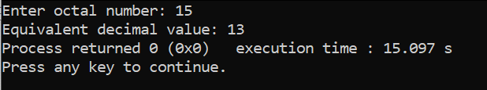

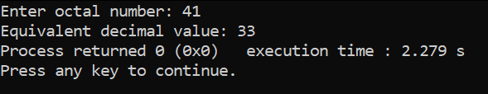

1. C Program to Convert Binary Number to Octal and vice-versa.

Binary Number to Octal number:

Code:

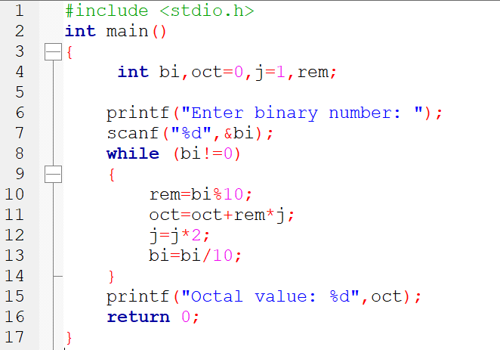

Output:

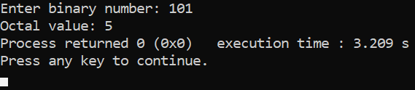

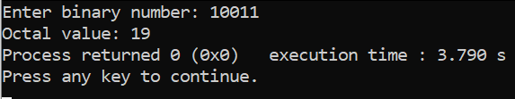

**Octal number to Binary number :**

**Code:**

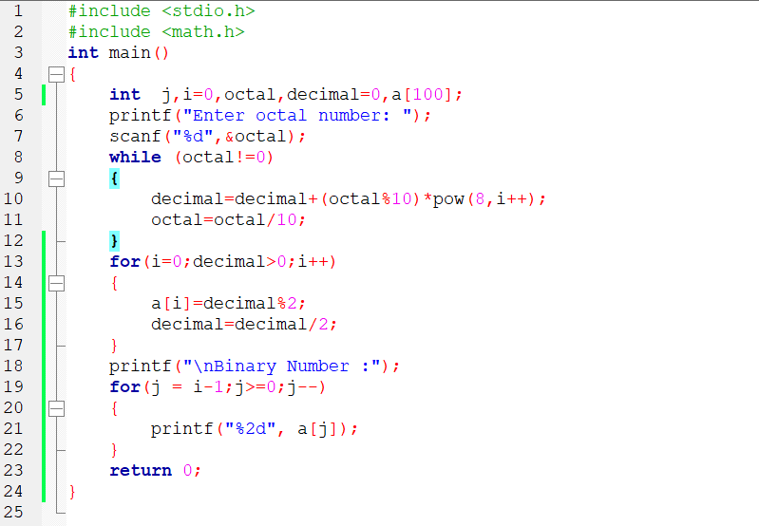

**Output:**

